**Classroom Fidgets**

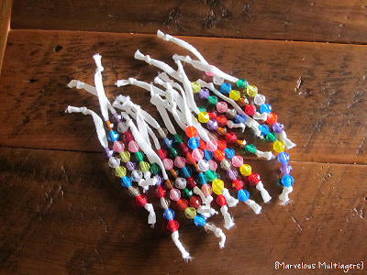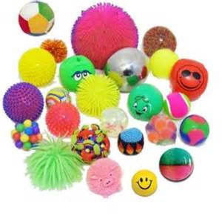

[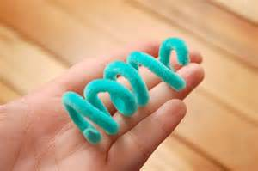](http://www.bing.com/images/search?q=pipe+cleaner+fidget+toy&view=detailv2&&id=65F22514531AF215A68D31436041C64DDC7CA900&selectedIndex=2&ccid=DTt1XYac&simid=607995347798525945&thid=JN.yIgcOJyQXE1jtWNJFJC93g)

**Pipe cleaner Beads on a string/ribbon Stress ball/squishy ball**

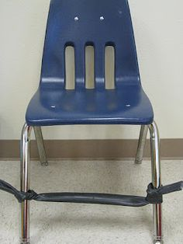

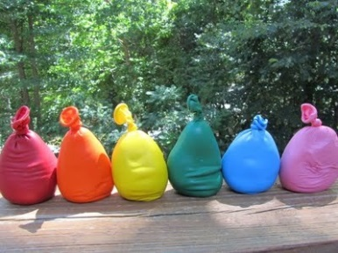

**Balloon filled with rice/play-dough Elastic band around bottom of chair**

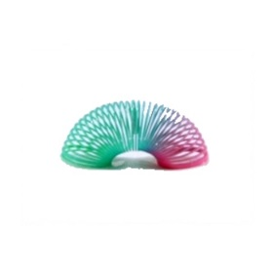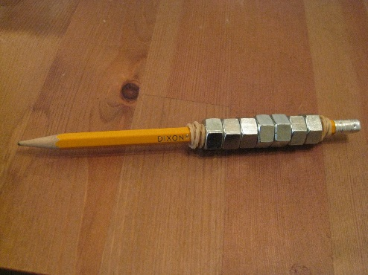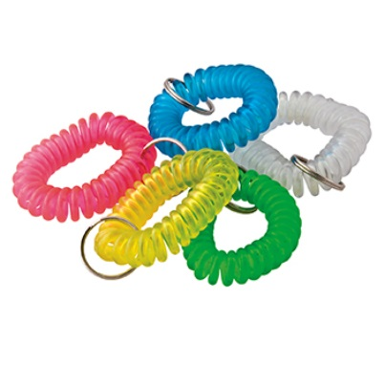

**Coiled keychain Hex nuts on a pencil Miniature slinky**